System Requirements Specification (SRS) –

Hospital Management System.

Doc. Ref. :

Version : 0.1

Status : Drafted

Created by :

Date :

1. Introduction 3

2. Functional Requirements 4

2.1 Admin Module 5

2.2 Patient Module 11

2.3 Doctor Module 17

2.4 Use Case Diagram 21

THIS DOCUMENT CONTAINS 19 NUMBERED PAGES

# Introduction

This document explains the system requirements and scope for developing Hospital Management System.

Hospital Management System can be categorized into four main parts: Admin, Doctor, Patient and the acknowledgement.

This document describes the system requirement of the Account part.

# Functional Requirements

The Account part of Hospital System has three modules which are divided 13 processes as described below.

|  |  |  |
| --- | --- | --- |
| **No** | **BRS requirement ID** | **Description** |
| **2.1** | **Admin Module** | |
| **2.1.1** | **H1** | **Login Process** |
| **2.1.2** | **H2** | **Add Doctor Process** |
| **2.1.3** | **H3** | **Remove Doctor Process** |
| **2.1.4** | **H4** | **Update Room Process** |
| **2.1.5** | **H5** | **Create Category Process** |
| **2.1.6** | **H6** | **Add Patient Process** |
| **2.1.7** | **H7** | **Remove Patient Process** |
| **2.1.8** | **H8** | **view Available Rooms** |
| **2.1.9** | **H9** | **View IPD Patient Process** |
| **2.1.10** | **H10** | **View Bill Process** |
| **2.2** | **Patient Module** | |
| **2.2.1** | **H11** | **Account Creation Process** |
| **2.2.2** | **H12** | **Login Process** |
| **2.2.3** | **H13** | **Forgot Password Process** |
| **2.2.4** | **H14** | **Search Room Process** |
| **2.2.5** | **H15** | **Book Room Process** |
| **2.2.6** | **H16** | **Browse Availability of Rooms** |
| **2.2.7** | **H19** | **Pay Bill Process** |
| **2.2.8** | **H20** | **View Generated Bill** |
| **2.3 Doctor Module** | | |
| **2.3.1** | **H21** | **Login Process** |
| **2.3.2** | **H22** | **Forgot Password Process** |
| **2.3.3** | **H23** | **View Schedule Process** |
| **2.3.4** | **H24** | **Update Schedule Process** |
| **2.3.5** | **H25** | **Cancel Meeting Process** |
| **2.3.6** | **H26** | **View Patient Process** |
| **2.3.7** | **H27** | **Prescribe Medicine Process** |
| **2.3.8** | **H28** | **Discharge The Patient** |

#### 2.1 Admin Module

**•** Administratorshould be responsible for the following activities**:**

### 2.1.1 Login Process

* Hospital Management System always compels user authentication before using itself except when a new account is successfully created.
* The user authentication demands UserID and Password. The UserID and the Password should be checked in three ways.
  + First, The UserID and the Password should be existed and correct.
* If The UserID and the Password are not equal to what the admin has registered, the admin authentication cannot be provided.
  + Second, the User Type linked to the UserID should be "Admin".
* When the User Type is "Admin", user can be placed on “Admin Home”.
  + Finally, UserID should be available.
* The Administrator can decide whether the UserID is available or suspended.
* If user is rejected, user authentication is not provided for system user.
* The admin account should be live for as long as the duration decided by Admin.
* Only when the three checks are successfully completed, Admin can be placed on respected page.
* The “Admin Home” provides some items as described below.

1. A trigger to logout
2. A trigger to update Account
3. A trigger to Change Password
4. A trigger to Add Doctor
5. A trigger to Remove Doctor
6. A trigger to Update Room
7. A trigger to Create Category
8. A trigger to View Available Rooms
9. A trigger to View IPD Patient
10. A trigger to View Bill

### 2.1.2 Add Doctor Process

### Admin first logs in to system.

* View his/her record.
* View the Doctor.
* Add the Doctor.
* The Doctor registration process requires information as below:

1. First Name.
2. Last Name.
3. Email Id.
4. Phone No.
5. Address.
6. Department.
7. Date Of Birth.
8. Date of Joining.

* After filling all required fields admin will click on register button.
* After successful registration, one UserID & Password would be generated automatically.

### 2.1.3 Remove Doctor Process

### Admin first logs in to system.

* View his/her record.
* View the Doctor.
* Remove the Doctor.
* List of Doctor would appear.
* Admin will check for doctor he/she wants to remove.
* Click on Delete.

### 2.1.4 Update Room Process

### Admin first logs in to system.

* View his/her record.
* View the Patient.
* Update the Room.
* List of Patient will appear.
* Select patient who desires to update the room.
* Click on edit.
* Details of Patient will appear with information as below:

1. First Name
2. Last Name
3. Phone No.
4. Address
5. Age
6. Gender
7. Problem Description
8. Doctor Appointed
9. Aadhar no.
10. Room Category.
    * Admin will select Room Category option and change category of room.
    * Each category has its own Price range, which would also be changed as room category will be changed.

### 2.1.5 Create Category Process

### Admin first logs in to system.

* View his/her record.
* Click on Create Category.
* Enter name of Room Category.
* Admin is required to set room price; different room category has its own price range which may vary depending on period of year.

### 2.1.6 Add Patient Process

### Admin first logs in to system.

* View his/her record.
* Add the Patient.
* Admin would require to fill information to book a room as below:

1. First Name
2. Last Name
3. Phone No.
4. Address
5. Age
6. Gender
7. Blood Group.
8. Problem Description
9. Doctor Appointed
10. Aadhar no.
11. Room Category.

* Once all required information would be filled admin is required to click on register button.
* After successful registration Patient information will be added to the database and One UserID and Password will be generated automatically.

### 2.1.7 Remove Patient Process

### Admin first logs in to system.

* View his/her record.
* View the Patient.
* Patients list will appear.
* Click on Remove option to remove the patient.

### 2.1.8 View Available Room

### Admin first logs in to system.

* View his/her record.
* View Available Room.
* Patient requires to select room category and price.
* After filling all required field person will click on search option.

### 2.1.9 View IPD Patient

### Admin first logs in to system.

* View his/her record.
* View the Patient.
* Click on Patient to see its details.

### 2.1.10 View Bill Process

### Admin first logs in to system.

* View his/her record.
* View the Patient.
* Click on Patient’s name for displaying its details.
* Click on the Bill Option.

## Patient Module

* Patient is the user of system who wants to book a bed.
* He is also able to view the availability of beds.

### Account Creation Process

* Hospital Management System compels to create the account before using it. So, Hospital Management System should provide the function which makes Patient creates new account.
* When Patient creates new account, the function demands two information described as below.

1. Login information
2. Contact Details

* The Login information

The Login information consists of some items described as below.

1. First Name
2. Last Name
3. Phone No.
4. Address
5. Age
6. Gender
7. Blood Group.
8. Problem Description
9. Doctor Appointed
10. Aadhar no.
11. Room Category.
    * All fields are mandatory.
    * UserID

* The UserID should be unique. If the UserID correspond with not case-sensitive to other which is previously registered, the UserID should not be registered as an account.
  + Password
* The Password has constraints which makes the Password consists of more than or equal 8 and less than or equal 16 characteristics including characters described as below.

1. Numeric figure (at least one)
2. Capital alphabet (A-Z) (at least one)
3. Small alphabet (a-z) (at least one)
4. Special character (#, $, %, &, etc.) (at least one)

* The Password is masked by dummy characters. The re-entering Password is demanded.
* The Password must be encrypted in Hospital Management System.
  + User Type

The User Type falls into three categories described as below.

1. Patient
2. Doctor
3. Administrator

* The User Type defines three types of users: "Patient user", "Doctor user", and "Administrator user”.
* In an Account Creation Process, the user can select Patient.
* No one could select The Administrator, because Administrator is added to Hospital Management System in advance.
* Contact Details
* The Contact Detail consists of some items described as below.

1. Permanent Address
2. Contact Phone No
   * All items are compulsory demanded.
   * Permanent Address

* Permanent Address should be filled.
* But only the state should be selected from options.
* The Security Question information

The Security Question information is needed when patient loses their Password. This information consists of two items described as below.

1. Selected Question
2. Answer
   * All fields are mandatory.
   * Some questions which are difficult to answer for anyone else are prepared in advance.

E.g. which color do you like most?

* + A question should be selected from options by the patient, and the Answer is registered by the patient.
* Login information should be entered on one screen, and then patient information and Security Question information should be entered on another screen.

### Login Process

* Hospital Management System always compels user authentication before using itself except when a new account is successfully created.
* The user authentication demands UserID and Password. The UserID and the Password should be checked in three ways.
  + First, The UserID and the Password should exist and and should be correct.
* If The UserID and the Password are not equal to what the user has registered, the user authentication cannot be provided.
  + Second, the User Type linked to the UserID should be "patient".
* When the User Type is "Patient", then user can be placed on “Patient Home”.
  + Finally, UserID should be available.
* The Administrator can decide whether the UserID is available or suspended – Refer to the SRS of the Admin part.
* If patient is rejected, user authentication is not provided for system user.
* The patient account should be live for as long as the duration decided by Admin.
* Only when the three checks are successfully completed, patient can be placed on respected page.
* The “Patient Home” provides items as described below.

1. A trigger to logout
2. A trigger to update Account
3. A trigger to Change Password
4. A trigger to Search Bed
5. A trigger to Book a Bed
6. A trigger to Update personal Information
7. A trigger to Request Delete Booking

### Forgot Password Process

* When system user lost their Password, the recovery method should be provided by Hospital Management system.

The recovery method is described as below.

* + First, system user enters their UserID for Hospital Management System.
  + Next, Hospital Management System demands the Answer which has been registered since when the Account was created.
  + Only when the Answer is correct, patient get the new password by E-mail which also has been registered since when the Account was created.
  + The new password is automatically generated by Hospital Management System.
* Of course, the new password should consist of more than or equal 8 and less than or equal 16 characteristics including at least a numeric figure, a capital alphabet, a small alphabet, and a special character.
* As a consequence, The Patient should get the patient authentication using the new password.
  + Then, the patient has to change the new password manually.
* If the Answer is not correct, otherwise, the correct Answer is demanded for user again.
  + In that case, Of course, patient couldn’t get the new password.

### Search Room Process

* Search conditions are described as below.

1. Room category
2. Price range
3. Enter name of Room Category.
4. Patient also requires to set room price; Different room category has their own price range which may vary depending on period of year.

### Book Room Process

* To book a room patient require to give information as below.

1. First Name
2. Last Name
3. Phone No.
4. Address
5. Age
6. Gender
7. Blood Group.
8. Problem Description
9. Doctor Appointed
10. Aadhar no.
11. Room Category.

* Hospital Management System should provide the function which makes the account updated for patient.
* The information patient could update is described below.

1. Login information
2. User information
3. Security Question Information

* The Login information

The updatable items as described below.

1. First Name
2. Last Name
3. E-mail address
   * All items are compulsory demanded, but updating is optional.

* The User information

The updatable items as described below.

1. User Name
2. User Phone No
3. E-mail address
4. Permanent address
5. Blood Group
   * All items are mandatory, but updating is optional.

* The Security Question information

The updatable items as described below.

1. Selected Question
2. Answer
   * All items are mandatory, but updating is optional.

### Browse Availability of Rooms

Search conditions are described as below.

* Room category
* Price range
* Enter name of Room Category.
* Patient also requires to set room price; Different room category has their own price range which may vary depending on period of year.

### 2.2.7 Pay Bill Process

### Patient first logs in to system.

* View his/her record.
* Pay the Bill.

### 2.2.8 View Generated Bill

### Patient first logs in to system.

* View his/her record.
* View the Bill.

## 2.3 Doctor Module

### 2.3.1 Login Process

* Hospital Management System always compels Doctor authentication before using itself except when a new account is successfully created.
* The user authentication demands UserID and Password. The UserID and the Password should be checked in three ways.
  + First, The UserID and the Password should be existed and correct.
* If The UserID and the Password are not equal to what the user has registered, the user authentication cannot be provided.
  + Second, the User Type linked to the UserID should be "user".
* When the User Type is " Doctor ", user can be placed on “Doctor Home”.
  + Finally, UserID should be available.
* The Administrator can decide whether the UserID is available or suspended – Refer to the SRS of the Admin part.
* If user is rejected, user authentication is not provided for doctor.
* The Doctor account should be live for as long as the duration decided by Admin.
* Only when the three checks are successfully completed, Doctor can be placed on respected page.
* The “Doctor Home” provides some items which are described as below.

1. A trigger to logout
2. A trigger to update Account
3. A trigger to Forgot Password
4. A trigger to Check Availability
5. A trigger to check Schedule
6. A trigger to Update Schedule
7. A trigger to Cancel Meeting
8. A trigger to View Patient Information
9. A trigger to Prescribe Medicine

### 2.3.2 Forgot Password Process

* When Doctor lost their Password, the recovery method should be provided by Hospital Management system.

The recovery method is described as below.

* + First, Doctor enters their UserID for Hospital Management System.
  + Next, Hospital Management System demands the Answer which has been registered since when the Account was created.
  + Only when the Answer is correct, Doctor gets the new password by E-mail which also has been registered since when the Account was created.
  + The new password is automatically generated by Hospital Management System.
* Of course, the new password should consist of more than or equal 8 and less than or equal 16 characteristics including at least a numeric figure, a capital alphabet, a small alphabet, and a special character.
* As a consequence, the Doctor could get the user authentication using the new password.
  + Then, the Doctor had better change the new password manually.
* If the Answer is not correct, otherwise, the correct Answer is demanded for doctor again.
  + In that case, Of course, Doctor couldn’t get the new password.

### 2.3.3 View Schedule Process

### Doctor first logs in to system.

* View his/her record.
* View the Schedule.
* A list of all appointment will appear with date and time.

#### 2.3.4 Update Schedule Process

### Doctor first logs in to system.

* View his/her record.
* View the Schedule.
* A list of all appointment will appear with date and time.
* Click on Update, Change date and time.
* Schedule will be updated.

**2.3.6 View Patient Process**

### Doctor first logs in to system.

* View his/her record.
* View the Patient.
* A list with patient name and other details will appear.

**2.3.7 Prescribe Medicine Process**

### Doctor first logs in to system.

* View his/her record.
* View the Patient.
* A list with patient name and other details will appear.
* Doctor will select patient who he wants to prescribe medicine.
* Detailed patient view will appear.
* Click on Prescribe medicine button.
* It will direct doctor to Prescribe medicine page where he/she can save medicine details.

**2.3.7 Discharge Patient Process**

### Doctor first logs in to system.

* View his/her record.
* View the Patient.
* A list with patient name and other details will appear.
* Doctor will select patient who he wants to discharge.
* A date will require to be provided by doctor to confirm discharge.

#### 2.5 Use Case Diagram

**Admin:**

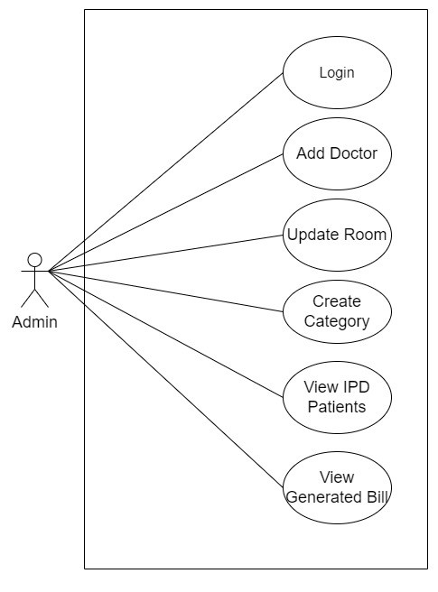

*Fig. Use case diagram for admin*

1. In Admin use case diagram Admin is the Actor.
2. Admin can handle following use cases:
3. Login
4. Add Doctor
5. Update Room
6. Create Category
7. View IPD Patient
8. View Generated Bill

**Doctor:**

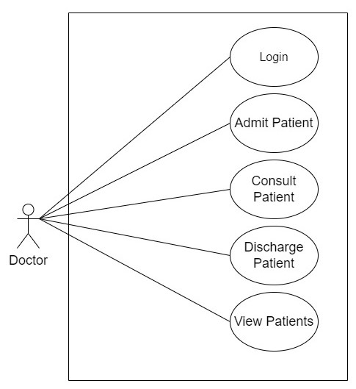

*Fig. Use case diagram for doctor*

1. In Doctor use case diagram Doctor is the Actor.
2. Doctor can handle following use cases:
3. Login
4. Admit Patient
5. Consult Patient
6. Discharge Patient
7. View Patients
8. Prescribe Medicine

**Patient:**

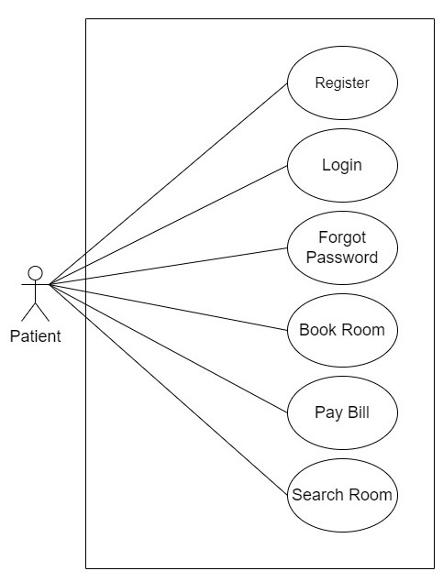

*Fig. Use case diagram for patient*

1. In Patient use case diagram Patient is the Actor**.**
2. Patient can handle following use cases:
3. Register
4. Login
5. Search Room
6. Book Room
7. Pay Bill
8. View Generated Bill